Java NIO的基础知识

# Java NIO(Java Non-blocking IO)-非阻塞式IO

## Java中的BIO与NIO

在java.io包及其子包中，提供了一般常用的IO流，这些IO流一般都是Blocking IO(阻塞式IO)。在java.nio包及其子包中，提供了非阻塞式IO(Non-blocking IO)。

## Java NIO技术核心三剑客

**Channel通道、Buffer缓冲区、Selector选择器**。

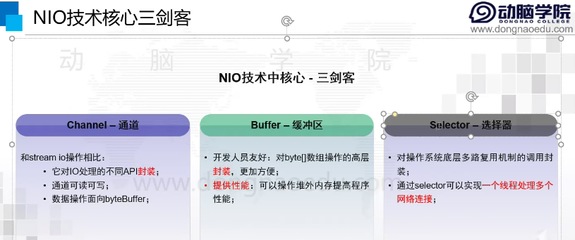

# Java NIO的基础知识

## 概念

### 阻塞与非阻塞

### 同步与异步

### 什么是NIO？

## Java NIO中的基本类

Channel通道、Buffer缓冲区、Selector选择器

FileChannel、SocketChannel、ServerSocketChannel

Scatter与Gather

# Channel通道

# Buffer缓冲区

## Buffer类存在于java.nio包中

在java.nio包中，提供了7中基本数据类型包装类(除了Boolean)的缓冲区：

ByteBuffer, CharBuffer, DoubleBuffer, FloatBuffer, IntBuffer, LongBuffer, ShortBuffer。

首先提供了**Buffer抽象类**，然后上面7个数据类型的缓冲类继承Buffer。

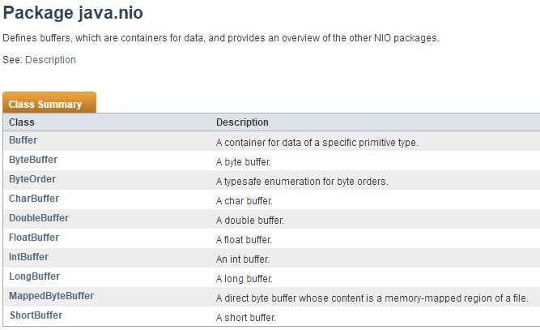

## Buffer抽象类介绍

public **abstract** class Buffer extends Object

A container for data of a specific primitive type.

A buffer is **a linear, finite sequence of elements of a specific primitive type**. Aside from its content, the essential properties of a buffer are **its capacity, limit, and position**:

**A buffer's capacity** is the number of elements it contains. The capacity of a buffer is never negative and never changes.

**A buffer's limit** is the index of the first element that should not be read or written. A buffer's limit is never negative and is never greater than its capacity.

**A buffer's position** is the index of the next element to be read or written. A buffer's position is never negative and is never greater than its limit.(position不能大于limit)

There is one subclass of this class for each non-boolean primitive type.

# Selector选择器